“”” Henry Chan “””

from flask import Flask, request, render_template

app = Flask(__name__)

@app.route('/', methods=['GET', 'POST'])

def calculate_tax():

if request.method == 'POST':

income = float(request.form.get('income'))

# Calculate MPF contribution

if income <= 85200: # If annual income is below $85,200, no MPF contributions are required

MPF_contribution = 0

else:

MPF_contribution = min(0.05 * income, 18000)

net_income = income - MPF_contribution - 132000 # Deduct the tax-free allowance HKD 132,000 in 2023/2024

if income >= 2500000:

# For extremely high annual income (e.g. over HKD2.5M), the actual amount is HKD2.022M in 2023/2024

# apply a standard tax rate of 15%, the actual standard tax rate, by the calculation from IRD tax calculator, it is not exactly 15%, it is slightly higher.

tax_payable = float(income-MPF_contribution) * 0.15

elif net_income <= 0: # If the net income is not positive, no tax is payable

tax_payable = 0

else:

# Apply the progressive tax calculation

bands = [(50000, 0.02), (50000, 0.06), (50000, 0.10), (50000, 0.14), (None, 0.17)]

remaining_income = net_income

tax_payable = 0

for band in bands:

if band[0] is None or remaining_income <= band[0]:

tax_payable += remaining_income * band[1]

break

else:

tax_payable += band[0] * band[1]

remaining_income -= band[0]

return render_template('result.html', MPF_contribution=MPF_contribution, tax_payable=tax_payable)

This Python code calculates the tax payable for individuals in Hong Kong based on their annual income. The code takes into account the Mandatory Provident Fund (MPF) contribution and the tax-free allowance of HKD 132,000 in 2023/2024.

If the annual income is below HKD 85,200, no MPF contributions are required. For incomes above this threshold, the MPF contribution is calculated as either 5% of the income or a maximum of HKD 18,000.

The net income is then calculated by deducting the MPF contribution and tax-free allowance from the annual income. If the net income is not positive, no tax is payable. For extremely high annual incomes over HKD 2.5 million, a standard tax rate of 15% is applied.

For other incomes, a progressive tax calculation is applied using different tax bands and rates. The code iterates through each band and calculates the tax payable based on the remaining income.

Overall, this Python code provides an efficient way to calculate taxes for individuals in Hong Kong based on their annual income and other relevant factors.

Standard Rate Example of 2500000

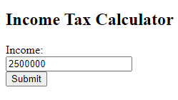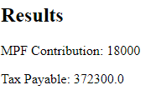

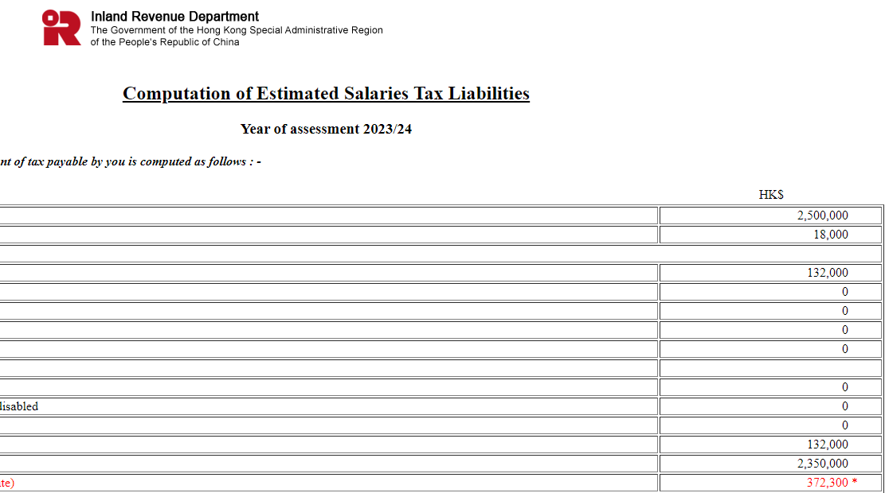

Standard Rate Example of 5000000

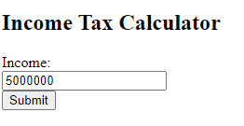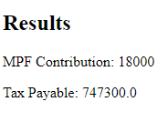

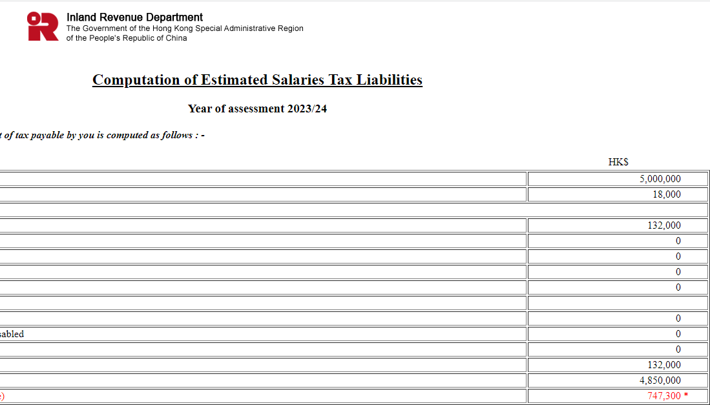

Progress Rate example of $ 250000

